Experiment 1
MEASUREMENT OF BASIC LENGTH

Instrument
1. Venier caliper;
2. Micrometer.

1. VERNIER CALIPER

1.1 Introduction

The Vernier Caliper is a precision instrument that can be used to measure internal and external distances extremely accurately. The details of a vernier principle are shown in Fig.1. An ordinary vernier caliper has jaws you can place around an object, and on the other side jaws made to fit inside an object. These secondary jaws are for measuring the inside diameter of an object. Also, a stiff bar extends from the caliper as you open it that can be used to measure depth. The accuracy which can be achieved is proportional to the graduation of the vernier scale.

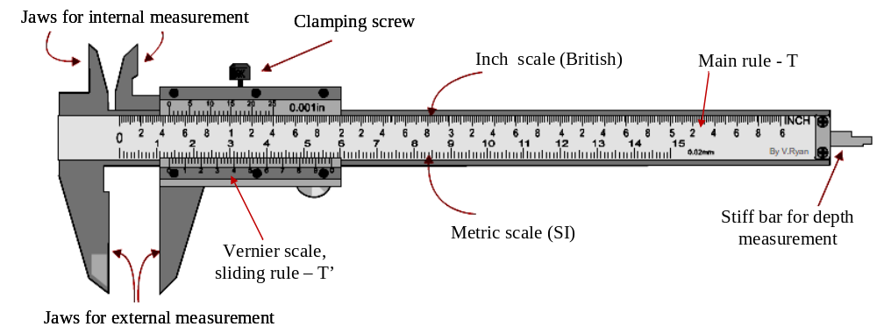

Fig.1. Structure of an ordinary vernier caliper

When the jaws are closed, the vernier zero mark coincides with the zero mark on the scale of the rule. The vernier scale (T’) slides along the main rule (T). The main rule allows you to determine the integer part of measured value. The sliding rule is provided with a small scale which is divided into equal divisions. It allows you to determine the decimal part of measured result in combination with the caliper precision (Δ), which is calculated as follows:
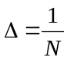 (1)
Where, N is the number of divisions on vernier scale (except the 0-mark), then, for N = 10 we have Δ = 0.1 mm, N = 20 we have Δ = 0.05 mm, and N = 50 we have Δ = 0.02 mm.

1.2 How to use a vernier caliper

- Preparation to take the measurement, loosen the locking screw and move the slider to check if the vernier scale works properly. Before measuring, do make sure the caliper reads 0 when fully closed.

- Close the jaws lightly on the item which you want to measure. If you are measuring something round, be sure the axis of the part is perpendicular to the caliper. Namely, make sure you are measuring the full diameter.  1.3 How to read a vernier caliper  In order to determine the measurement result with a vernier caliper, you can use the following equation:  D = n . a + m . Δ (2)  Where, a is the value of a division on main rule (in millimeter), i.e., a = 1 mm, Δ is the vernier precision and also corresponding to the value of a division on sliding rule that you can either find it on the caliper body or determine it’s value using the eq. (1).  - Step 1: Count the number of division (n) on the main rule – T, lying to the left of the 0-mark on the vernier scale – T’ (see example in Fig. 2a)  - Step 2: Look along the division mark on vernier scale and the millimeter marks on the adjacent main rule, until you find the two that most nearly line up. Then, count the number of divisions (m) on the vernier scale except the 0-mark (see example in Fig. 2b).  - Step 3: Put the obtained values of n and m into eq. (2) to calculate the measured dimension as shown in Fig.2c.  Remember:  + If 0-mark on vernier scale lies adjacently behind the division n on main rule, the division m would be on the first part of vernier scale. | 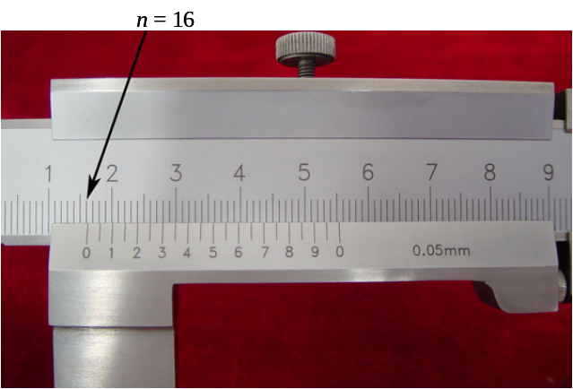  (a)  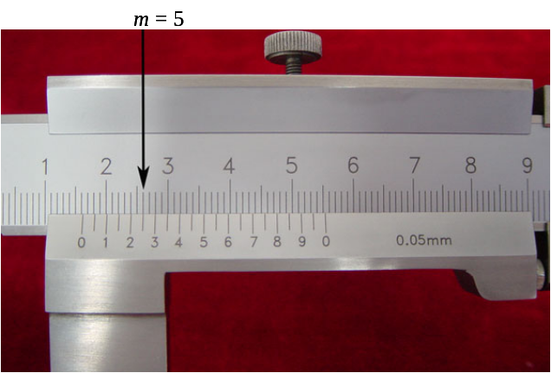  (b)  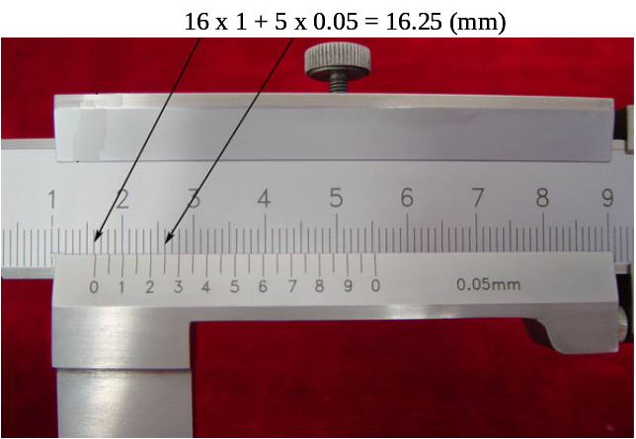  (c)  Fig.2. Method to read vernier caliper
+ If 0-mark on vernier scale lies between the division n and n+1 on main rule, the division m would be on the middle part of vernier scale.
+ If 0-mark on vernier scale lies adjacently the division n+1 on main rule, the division m would be on the last part of vernier scale.

II MICROMETER

2.1 Introduction

The micrometer is a device incorporating a calibrated screw used widely for precise measurement of small distances in mechanical engineering and machining. The details of a micrometer principle are shown in Fig.3. Each revolution of the rachet moves the spindle face 0.5mm towards the anvil face. The longitudinal line on the frame is graduated with 1 millimetre divisions and 0.5 millimetre subdivisions. An axial line (called referent one) divides the main rule into two parts: top and bottom half. Therefore, the main rule is called “double one”. The thimble has 50 graduations, each being 0.01 millimetre (one-hundredth of a millimetre). It means that the precision (Δ) of micrometer has the value of 0.01. Thus, the reading is given by the number of millimetre divisions visible on the scale of the sleeve plus the particular division on the thimble which coincides with the axial line on the sleeve.

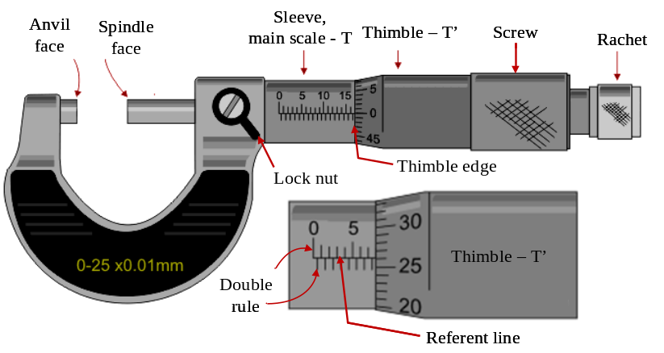
Fig.3. Structure of an ordinary micrometer

2.2 How to use a micrometer

- Start by verifying zero with the jaws closed. Turn the ratcheting knob on the end till it clicks. If it isn't zero, adjust it.
- Carefully open jaws using the thumb screw. Place the measured object between the anvil and spindle face, then turn ratchet knob clockwise to the close the around the specimen the till it clicks. This means that the rachet cannot be tightened any more and the measurement can be read.

2.3 How to read a micrometer

In order to determine the measurement result with a vernier caliper, you can also use the following equations:  D = n . a + m . Δ (3)  or: D = n . a + m . Δ + 0.50 (4)  Where, a is the value of a division on sleeve -main rule (in millimeter), i.e., a = 1 mm, Δ is the vernier precision and also corresponding to the value of a division on thimble (Δ = 0.01 mm).  - Step 1: Count the number of division (n) on the sleeve - T (on top half), lying to the left of the thimble edge.  - Step 2: Look at the thimble divisions mark – T’ to find the one that coincides nearly a line with the referent one. Then, count the number of divisions (m) on the thimble except the 0-mark  - Step 3: Put the obtained values of n and m into eq. (3) to calculate the measured dimension as shown in Fig.4a. In case of that one additional 0.5 | 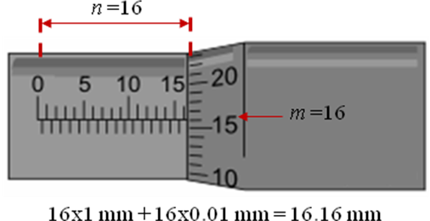  (a)  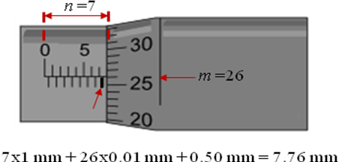  (b)  Fig. 4. Method to read micrometer
subdivision (on bottom half) between the division n and thimble edge were visible, use the eq. (4) instead to calculate the measured dimension as shown in Fig.4b.

Remember:  The rachet is only considered to move completely a revolution around the sleeve when the 0-mark on the thimble passes the referent line. As an example shown in Fig.5, it seems that you can read the value of n as 3, however, due to the 0-mark on the thimble lies above the referent line, then this parameter is determined as 2. In this case, you would apply the eq. (4) to calculate the measured dimension. | 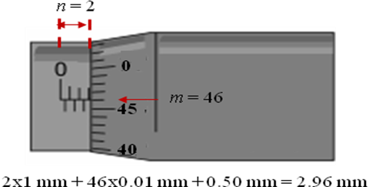  Fig.5. Rachet does not move completely a revolution around the sleeve, yet.

III. EXPERIMENTAL PROCEEDURE

1. Use the vernier caliper to measure the height (h), external and internal diameter (D and d, respectively) of a metal hollow cylinder (Fig.6) based on the method of using and reading this rule presented in part 1.2 and 1.3.  Note: do 5 trials for each parameter.  2. Use the vernier micrometer to measure the diameter (D_{b}) of a small steel ball for 5 trials based on the method of using and reading this device presented in part 2.2 and 2.3. | 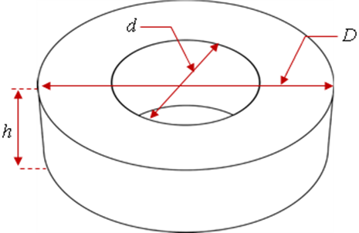  Fig.6. Metal hollow cylinder for measurement

IV. PROCESSING OF MEASUREMENT DATA

Your lab report should include the following issues:
1. A table including the measurement data with the height (h), external and internal diameter (D and d, respectively) of metal hollow cylinder.
2. A table including the measurement data with the diameter (D_{b}) of small steel ball.
3. Calculate the volume and density of the metal hollow cylinder using the following equations:
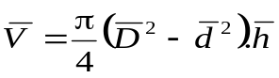 (5)
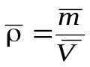 (6)
4. Calculate the volume of the steel ball using the following equation:
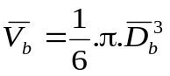 (7).
5. Calculate and comment the uncertainties of volume and density of the metal hollow cylinder as well as the volume of the steel ball.
6. Write the last result of those quantities in the form like this expression: 